Accessing Green Climate Fund

Challenges and opportunities
Mohammad Mejbahuddin
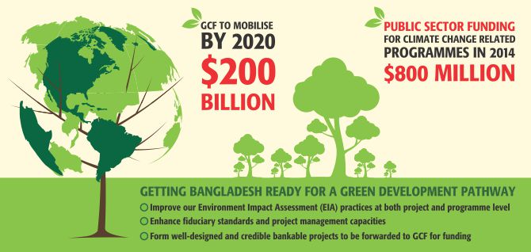
Bangladesh is one of the most vulnerable countries to climate change. The poor and the marginal groups stand to suffer the most from adverse climate effects. Change in the climate is also having a disproportionately large impact on the life, property and livelihoods of poor groups in Bangladesh. The concerns and vulnerability of poor and vulnerable people should be the warp and woof of our strategy for implementing a climate resilient development pathway.
The investment required for undertaking adaptation and mitigation efforts is huge. As public sources for meeting this investment demand are inadequate, it is necessary that external funding and private flows, both domestic and international, bring complimentary financial resources to bridge the gap. Yearly public sector funding in Bangladesh for climate change related programmes and projects reached approximately $800 million in FY14.
One of the remarkable successes at COP-15 (Copenhagen Climate Summit) in 2009 was securing firm funding commitments for climate change adaptation and mitigation in developing countries. Developed countries in that meeting agreed to provide 'new and additional' resources to the tune of $100 billion per annum by 2020 with balanced allocation between adaptation and mitigation. Consequently, the Green climate Fund (GCF) was established in COP-16 in 2010 under the United Nations Framework Convention on Climate Change (UNFCCC). The fund will be available for member countries in coping with and adapting to the effects of climate change. The governing board of the GCF has decided to use its funds equally for adaptation and mitigation purposes on 50/50 basis. The GCF aims to mobilise $200 billion by 2020.
The recent UNFCCC process has reinforced the importance of strong national climate strategies as well as in-country institutional structures, and there were strong urgings within these discussions on “direct access.” These discourses have made me share my personal thoughts in the context of GCF, while my organisation has been nominated as National Designated Authority (NDA) of Bangladesh to the fund. Direct access to climate fund is a long-standing expectation of Bangladeshi institutions, as this also demonstrates recognition of the strength of our national institutions in global standard. As NDA of Bangladesh for GCF, I had been looking at the matters very carefully, and found that the process of direct access is difficult and challenging, but also brings opportunities for institutional capacity development.
GCF is expected to play a key role in channeling new, additional, adequate and predictable financial resources to developing countries. The GCF is different from many other global funds as it will be scalable and flexible in nature and necessarily meant to maximise the impact of adaptation and mitigation actions in a way that it transforms the business-as-usual development, while bring environmental, social, economic and development benefits in a more inclusive and gender-sensitive way.
GCF will start to receive project/programme for funding from least developed countries, small island countries and African states from June 2015. The government is keen on accreditation of its potential National Implementing Entities (NIE) with GCF so that accredited NIEs can start implementing climate change projects immediately. NDA is trying hard to support the national entities so that a few of the national institutions are accredited to GCF and direct access is significantly enhanced.
Last week, NDA organised a two-day workshop, where 14 national entities reviewed their capacity self-assessment with the direct guidance of GCF representative and an international expert. We are very encouraged by the interest of the national institutions, and the way they are stepping up to get ready for accreditation is highly appreciable. However, the process is challenging and there are opportunities to gain direct access to GCF. We need to take a pragmatic path in accreditation process. I will highlight a few steps here.
Advertisement

The first and most important step should be improving institutional capacity in the area of environmental and social safeguard policy and practices. We have Environment Impact Assessment (EIA) guideline, which is widely practiced both in public and private sector projects, and this EIA includes social safeguard issues as well. However, we need to improve our EIA practices at both project and programme level.
The second step will be to enhance the fiduciary standards and project management capacities. This might demand strong effort as the fiduciary standards needed might not be seen within one entity, as we follow a wider institutional architecture in fiduciary risk management of our public funds, where auditor general's office, accounts department, finance cell of different ministries, internal audit and monitoring process of different institutions, implementation, monitoring and evaluation by IMED and accountability through public accounts committee play critical roles, and all these needs to be factored. Therefore, the task is not easy and the capacities need to be properly articulated, maintained, recorded and presented in favour of the fiduciary standards in the accreditation application process. We also need to be frank and self-stimulating in meeting the gaps, if any, in the self-assessment process.
The third, and in my view most critical, thing is to have well designed and credible bankable projects or programmes to be forwarded to GCF for funding. We have a significant number of project ideas developed by different ministries. These ideas will be translated into bankable projects for submission to GCF. This requires further effort and will probably be the most important task before us in the near future to get access to GCF.
I am hopeful that Bangladesh will be able to directly access funding from GCF in the near future. I am optimistic about the potential of GCF in transforming the development landscape in addition to the development aid that we get under ODA.
The writer is the Senior Secretary of Economic Relations Division and National Designated Authority of Bangladesh to Green Climate Fund, Bangladesh.
Published: 12:00 am Thursday, February 05, 2015
http://www.thedailystar.net/op-ed/challenges-and-opportunities-63251

